Implementation Phase Report

Title: Database management application for student and library management

List of Team Members:
Akash Bilgi – 2bv14is007
Amrutha Alewoor – 2bv14is013
Ankita K R – 2bv14is017
Abhijit K – 2bv14is001

Team Leader: Akash Bilgi

Responsibilities:
Akash: Backend/Frontend, HTML code, Views, Authentication tables.
Abhijith: Linking and tables.
Amrutha: Search design,Views
Ankita: User, Book Data collection

Design updating:

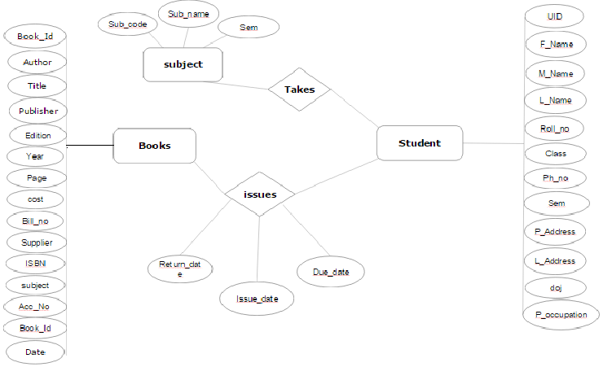

Question1: Give the SQL statement(s) used to create the Oracle/MySQL database tables needed to implement the normalized relational schema.

db.define_table(
'Books',
Field('Book_id','string',requires=[IS_NOT_EMPTY(),IS_NOT_IN_DB(db,'Books.Book_id')]),
Field('Date_','date',requires=IS_NOT_EMPTY()),
Field('Author','string',requires=IS_NOT_EMPTY()),
Field('Title','string',requires=IS_NOT_EMPTY()),
Field('publisher','string',requires=IS_NOT_EMPTY()),
Field('Edition','string',requires=IS_NOT_EMPTY()),
Field('year_','integer',requires=IS_NOT_EMPTY()),
Field('page_','integer',requires=IS_NOT_EMPTY()),
Field('cost_','float',requires=IS_NOT_EMPTY()),
Field('Bill_no','string',requires=IS_NOT_EMPTY()),
Field('call_no','string',requires=IS_NOT_EMPTY()),
Field('Supplier','string',requires=IS_NOT_EMPTY()),
Field('ISBN','string'),
Field('Subject','string',requires=IS_NOT_EMPTY()))

db.define_table(
'Book_acc',
Field('Acc_no','string',requires=IS_NOT_EMPTY()),
Field('Book_id','string',requires=IS_NOT_EMPTY()),
Field('call_no','string',requires=IS_NOT_EMPTY()))

db.define_table(
'student_info',
Field('u_id','string',requires=[IS_NOT_EMPTY(),IS_NOT_IN_DB(db,'student_info.u_id')]),
Field('F_name','string',requires=IS_NOT_EMPTY()),
Field('M_name','string',requires=IS_NOT_EMPTY()),
Field('L_name','string',requires=IS_NOT_EMPTY()),
Field('Roll_no','string',requires=IS_NOT_EMPTY()),
Field('Class_','string',requires=IS_NOT_EMPTY()),
Field('sem','string',requires=IS_NOT_EMPTY()),
Field('l_address','text',requires=IS_NOT_EMPTY()),
Field('l_phone_no','string',requires=IS_NOT_EMPTY()),
Field('p_address','text',requires=IS_NOT_EMPTY()),
Field('p_phone_no','string',requires=IS_NOT_EMPTY()),
Field('doj_date','date',requires=IS_NOT_EMPTY()),
Field('p_occupation','string',requires=IS_NOT_EMPTY()))

db.define_table(
'Subject',
Field('sub_code','string',requires=[IS_NOT_EMPTY(),IS_NOT_IN_DB(db,'Subject.sub_code')]),
Field('sub_name','string',requires=IS_NOT_EMPTY()),
Field('sem','string',requires=IS_NOT_EMPTY()))

db.define_table(
'Sub_taken',
Field('u_id','string',requires=IS_NOT_EMPTY()),
Field('sub_code','string',requires=IS_NOT_EMPTY()))

db.define_table(
'ISSUE',
Field('u_id','string',requires=IS_NOT_EMPTY()),
Field('Acc_no','integer',requires=[IS_NOT_EMPTY()]),
Field('Return_date','date'),
Field('Issue_date','date',requires=IS_NOT_EMPTY()),
Field('Due_date','date',requires=IS_NOT_EMPTY()))
Question2: Give the actual data stored in each table of the database. (samples)
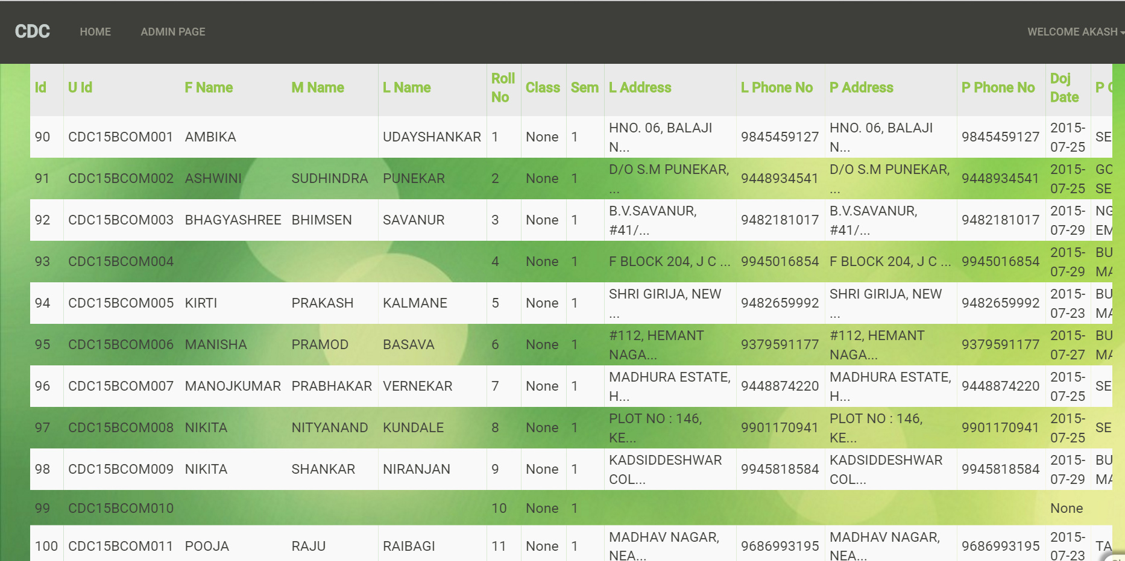
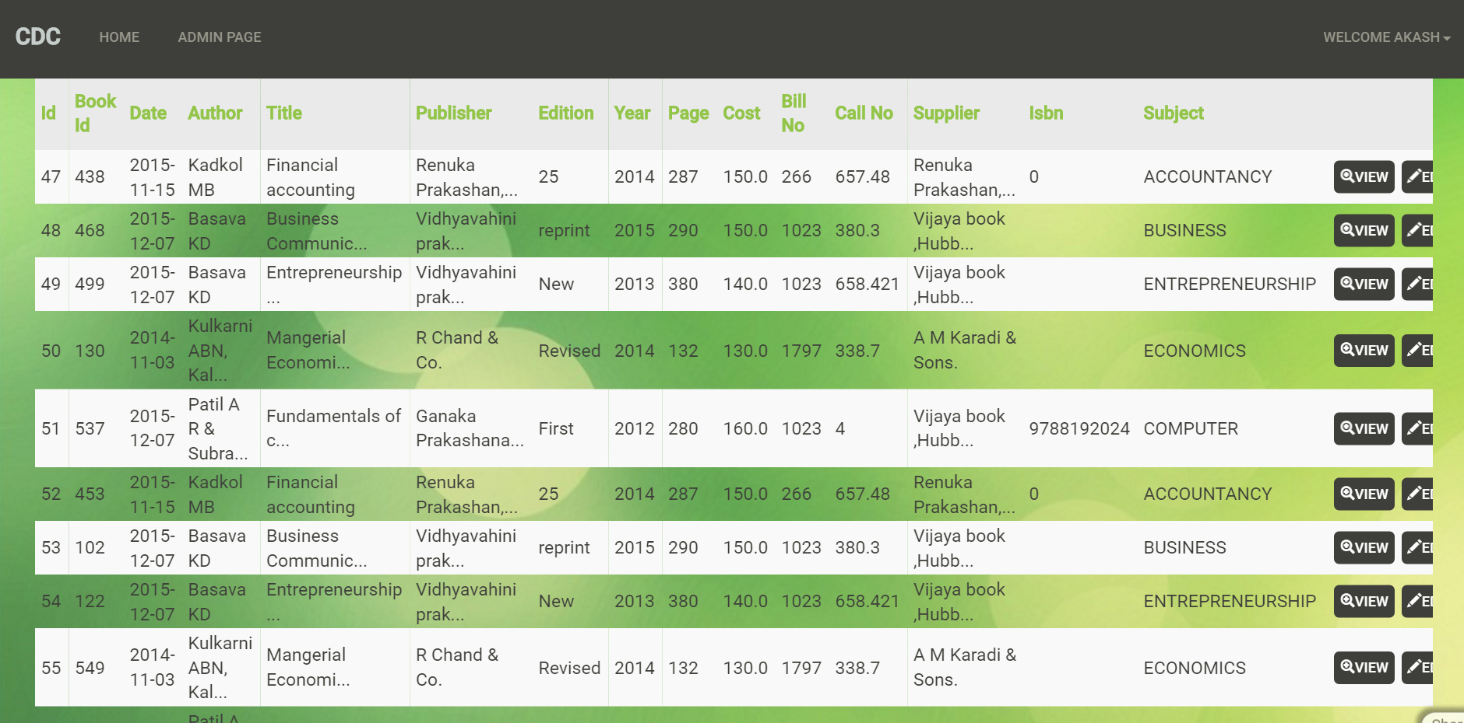
Question3: Give the snapshots, description and SQL queries for each of the user interface forms for your application. (Create the front end using python and hook it up to the SQL.) 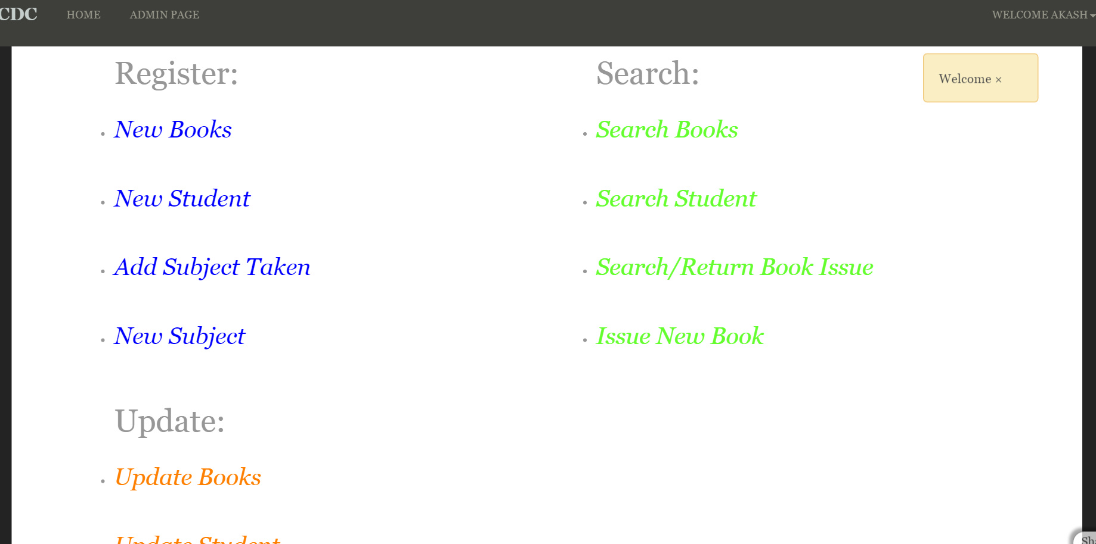

@auth.requires_login()
@auth.requires_membership('user_1')
def createstudent():
form = SQLFORM(db.student_info)
if form.process().accepted:
response.flash="Student created"
return dict(form=form)

@auth.requires_membership('user_1')
def show1():
response.flash = T("Welcome")
return dict(message=T('Welcome to web2py!'))

@auth.requires_membership('user_1')
def createSub_taken():
form = SQLFORM(db.Sub_taken)
if form.process().accepted:
response.flash="Sub_taken created"
return dict(form=form)
@auth.requires_membership('user_1')
def createISSUE():
form = SQLFORM(db.ISSUE)
if form.process().accepted:
response.flash="ISSUE created"
return dict(form=form)
@auth.requires_membership('user_1')
def createSubject():
form = SQLFORM(db.Subject)
if form.process().accepted:
response.flash="Subject created"
return dict(form=form)
@auth.requires_membership('user_1')
def createBook_acc():
form = SQLFORM(db.Book_acc)
if form.process().accepted:
response.flash="Book_acc created"
return dict(form=form)
@auth.requires_membership('user_1')
def createBooks():
form = SQLFORM(db.Books)
if form.process().accepted:
response.flash="Books created"
return dict(form=form)
@auth.requires_membership('user_1')
def register():
form=SQLFORM.factory(db.Books,db.Book_acc,db.student_info,db.Subject,db.Sub_taken,db.ISSUE)
if form.process().accepted:
response.flash='Thanks for filling the form'
return dict(form=form)
@auth.requires_membership('user_1')
def display_form():
Search=FORM('Enter name:', INPUT(_name='name'), INPUT(_type='submit'))
rows=db(db.student_info.F_name==(request.vars.name)).select(db.student_info.ALL)
return locals()

@auth.requires_membership('user_1')
def display_form2():
Search=FORM('Enter UID:', INPUT(_name='name'), INPUT(_type='submit'))
rows=db(db.student_info.u_id==(request.vars.name)).select(db.student_info.ALL)
SearchName=FORM('Enter Name:', INPUT(_name='name1'), INPUT(_type='submit'))
rows1=db(db.student_info.F_name==(request.vars.name1)).select(db.student_info.ALL)
return locals()

@auth.requires_membership('user_1')
def display_form3():
Search=FORM('Enter UID:', INPUT(_name='name'), INPUT(_type='submit'))
Books=db(db.ISSUE.u_id==(request.vars.name)).select(db.ISSUE.ALL)
Student=db(db.student_info.u_id==(request.vars.name)).select(db.student_info.ALL)
Return=FORM('Enter UID:', INPUT(_name='name3'), 'Enter Acc:', INPUT(_name='name1'), ' Enter Return Date(yyyy/mm/dd):', INPUT(_name='name2'), INPUT(_type='submit'))
db(db.ISSUE.Acc_no==(request.vars.name1))(db.ISSUE.u_id==(request.vars.name3)).update(Return_date=(request.vars.name2))
#OB.update_record(Return_date=(request.vars.return_date))
#db(db[tablename]._id==id).update(**{fieldname:value})
#OB.update_record(Return_date=(request.vars.return_date))
#row = db(db.ISSUE.Acc_no==(request.vars.acc))
#row.update(Return_date=(request.vars.return_date))
return locals()

@auth.requires_membership('user_1')
def display_books():
Search=FORM('Enter Book ID:', INPUT(_name='name'), INPUT(_type='submit'))
Books=db(db.Books.Book_id==(request.vars.name)).select(db.Books.ALL)
call=db(db.Book_acc.Book_id==(request.vars.name)).select(db.Book_acc.Book_id,db.Book_acc.Acc_no,db.Book_acc.call_no)
return locals()
@auth.requires_membership('user_1')
def display_form4():
Search=FORM('Enter UID:', INPUT(_name='name'), INPUT(_type='submit'))
Books=db(db.ISSUE.u_id==(request.vars.name)).select(db.ISSUE.ALL)
Return=FORM('Enter Acc No and return date:',INPUT(_name='AccNo'),INPUT(_name='Return'), INPUT(_type='submit'))
return locals()

def update():
Search=FORM('Enter UID:', INPUT(_name='name'), INPUT(_type='submit'))
Books=db(db.ISSUE.u_id==(request.vars.name),readonly=True ).select(db.ISSUE.ALL)
Return=FORM('Enter Acc No and return date:',INPUT(_name='AccNo'),INPUT(_name='Return'), INPUT(_type='submit'))
return locals()

def build_form(readonly=False):
#create fields or get from
Search=FORM('Enter UID:', INPUT(_name='name'), INPUT(_type='submit'))
field2=db.ISSUE.u_id
field2.default='123'
#give it to the
form = SQLFORM.factory( *[field2], readonly=readonly )

def frm():
Search=FORM('Enter UID:', INPUT(_name='name'), INPUT(_type='submit'))
form=SQLFORM.smartgrid(db.ISSUE)
return locals()

@auth.requires_membership('user_1')
def updateissue():
form=SQLFORM.smartgrid(db.ISSUE)
return locals()
@auth.requires_membership('user_1')
def updatestudent():
form=SQLFORM.smartgrid(db.student_info)
return locals()
@auth.requires_membership('user_1')
def updatebooks():
form=SQLFORM.smartgrid(db.Books)
return locals()
@auth.requires_membership('user_1')
def updateSubject():
form=SQLFORM.smartgrid(db.Subject)
return locals()
@auth.requires_membership('user_1')
def updatesubjecttaken():
form=SQLFORM.smartgrid(db.Sub_taken)
return locals()
@auth.requires_membership('user_1')
def list_users():
btn = lambda row: A("Edit", _href=URL('manage_user', args=row.auth_user.id))
db.auth_user.edit = Field.Virtual(btn)
rows = db(db.auth_user).select()
headers = ["ID", "Name", "Last Name", "Email", "Edit"]
fields = ['id', 'first_name', 'last_name', "email", "edit"]
table = TABLE(THEAD(TR(*[B(header) for header in headers])),
TBODY(*[TR(*[TD(row[field]) for field in fields]) \
for row in rows]))
table["_class"] = "table table-striped table-bordered table-condensed"
return dict(table=table)

@auth.requires_membership('user_1')
def manage_user():
user_id = request.args(0) or redirect(URL('list_users'))
form = SQLFORM(db.auth_user, user_id).process()
membership_panel = LOAD(request.controller,
'manage_membership.html',
args=[user_id],
ajax=True)
return dict(form=form,membership_panel=membership_panel)

@auth.requires_membership('user_1')
def manage_membership():
user_id = request.args(0) or redirect(URL('list_users'))
db.auth_membership.user_id.default = int(user_id)
db.auth_membership.user_id.writable = False
form = SQLFORM.grid(db.auth_membership.user_id == user_id,
args=[user_id],
searchable=False,
deletable=False,
details=False,
selectable=False,
csv=False,
user_signature=False)
return form

Submission Date:25-04-2016

